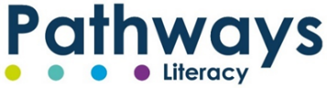

ORDER FORM
Name of School: |  |  |  | Name of nominated contact:
E-mail address for electronic resources to be sent to (nominated contact):
Contact name and email address for invoicing and method of payment including PO number if applicable:
Please place an ‘X’ for products required |  |  | Remarks/Comments e.g. Indicate year groups if whole school package not required | Please place an ‘X’ for products required |  | Remarks/Comments e.g. Indicate year groups if whole school package not required
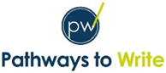 |  |  | Please complete unit selection below. Note there are 2 and ensure you complete the one relevant to you.
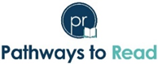 |  |  | Please complete unit selection below. Please note that it comes after the Pathways to Write selection tables. | 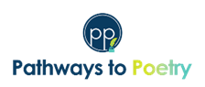
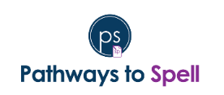 |  |  |  | 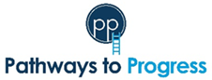
Terms and conditions of the purchase of Pathways to Home Learning, Pathways to Progress, Pathways to Read, Pathways to Poetry, Pathways to Spell and Pathways to Write (Pathways Literacy):
All materials and property relating to Pathways Literacy are wholly owned by The Literacy Company Ltd. Unauthorised use of all materials, distribution of materials, or republication without prior written approval of The Literacy Company Ltd, is strictly prohibited. This includes all Literacy Company materials purchased by any school via a third-party provider (e.g. Balance). The names and logos of Pathways Literacy remain the property of The Literacy Company Ltd and may not be used without prior written approval. As all resources are electronic, we cannot process any exchanges or refunds once the resources have been issued.
Name of School:
Signature (I accept the conditions above):
Date: Click or tap to enter a date.
When do you intend to implement the programme(s) in school?: Click or tap to enter a date.
How did you hear about us? Choose an item.
Referral code (if applicable):
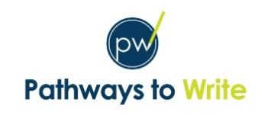
Pathways to Write single year group classes unit selection
Mixed-age selection on next page
Year group | Autumn term |  | Spring term |  | Summer term
 | Autumn 1 | Autumn 2 | Spring 1 | Spring 2 | Summer 1 | Summer 2
EYFS | Choose an item. | Choose an item. | Choose an item. | Choose an item. | Choose an item. | Choose an item.
Year 1 | Choose an item. | Choose an item. | Choose an item. | Choose an item. | Choose an item. | Choose an item.
Year 2 | Choose an item. | Choose an item. | Choose an item. | Choose an item. | Choose an item. | Choose an item.
Year 3 | Choose an item. | Choose an item. | Choose an item. | Choose an item. | Choose an item. | Choose an item.
Year 4 | Choose an item. | Choose an item. | Choose an item. | Choose an item. | Choose an item. | Choose an item.
Year 5 | Choose an item. | Choose an item. | Choose an item. | Choose an item. | Choose an item. | Choose an item.
Year 6 | Choose an item. | Choose an item. | Choose an item. | Choose an item. | Choose an item. | Choose an item.
Any notes:

Pathways to Write mixed-age classes unit selection
If your class structure is not in line with the year groups below, please contact us for support with your unit selection.
Year group | Autumn term |  | Spring term |  | Summer term
 | Autumn 1 | Autumn 2 | Spring 1 | Spring 2 | Summer 1 | Summer 2
EYFS | Choose an item. | Choose an item. | Choose an item. | Choose an item. | Choose an item. | Choose an item.
Year 1/2 class  First year | Choose an item. | Choose an item. | Choose an item. | Choose an item. | Choose an item. | Choose an item.
Year 1/2 class  Second year | Choose an item. | Choose an item. | Choose an item. | Choose an item. | Choose an item. | Choose an item.
Year 3/4 class  First year | Choose an item. | Choose an item. | Choose an item. | Choose an item. | Choose an item. | Choose an item.
Year 3/4 class  Second year | Choose an item. | Choose an item. | Choose an item. | Choose an item. | Choose an item. | Choose an item.
Year 5/6 class  First year | Choose an item. | Choose an item. | Choose an item. | Choose an item. | Choose an item. | Choose an item.
Year 5/6 class  Second year | Choose an item. | Choose an item. | Choose an item. | Choose an item. | Choose an item. | Choose an item.
Any notes:

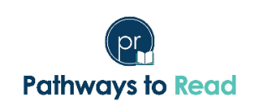
Pathways to Read unit selection
Year group | Autumn term |  | Spring term |  | Summer term
 | Autumn 1 | Autumn 2 | Spring 1 | Spring 2 | Summer 1 | Summer 2
Year 1 | P2R begins in Sp1 for Y1 to allow for transition | P2R begins in Sp1 for Y1 to allow for transition | Choose an item. | Choose an item. | Choose an item. | Choose an item.
Year 2 | Choose an item. | Choose an item. | Choose an item. | Choose an item. | Choose an item. | Choose an item.
Year 3 | Choose an item. | Choose an item. | Choose an item. | Choose an item. | Choose an item. | Choose an item.
Year 4 | Choose an item. | Choose an item. | Choose an item. | Choose an item. | Choose an item. | Choose an item.
Year 5 | Choose an item. | Choose an item. | Choose an item. | Choose an item. | Choose an item. | Choose an item.
Year 6 | Choose an item. | Choose an item. | Choose an item. | Choose an item. | Choose an item. | Choose an item.
Any notes:
Please note: there are not always two choices of Pathways to Read units. Texts with ‘(Set 1&2)’ following the book title, will link to both set 1 and set 2 Pathways to Write units through theme or genre.

Price List
Pathways to Write – Single age |  | Pathways to Write – Mixed age |  | Pathways to Read
Full package (EYFS-Y6) inc Exemplifications (Y1-Y6) | £1975 | Mixed age full package (EYFS, Cycle A and B Y1/2, Y3/4, Y5/6) inc Exemplifications | £1975 | Full package (Y1-Y6) | £1675
Single year group package | £315 | EYFS & Mixed age planning Cycle A or B | £1200 | Single year group Y2-Y6 (Y1 only) | £325 (£150)
KS1 package (EYFS-Y2) | £875 | Mixed age planning Cycle A or B (Y1/2, Y3/4, Y5/6) | £950 | KS2 package (Y3-Y6) | £1300
KS2 package (Y3-Y6) | £1215 | Mixed age single year group package Cycle A or B | £325 | Y1 only for existing P2R schools | £100

Pathways to Write and Read additional units
 | Non-Pathways Schools | P2W/P2R schools
Individual themed units | £40 | £30
Set of themed units (EYFS-Y6) | £250 | £189
7-20 units at 10% discount (per unit) | N/A | £27
21-30 units at 15% discount (per unit) | N/A | £25.50
31+ units at 20% discount (per unit) | N/A | £24

Pathways to Poetry |  | Pathways to Spell |  | Pathways to Progress
Full Package EYFS-Y6 | £300 | Full package (Y1-Y6) | £395 | Cost Year 1 |  | Ongoing access to subject knowledge videos – annual subscription
Single Year Group (6 units) | £45 | KS1 package (Y1-Y2) | £180 | Full Package Y1-Y6 | £1295 | £200
Individual Poetry unit | £7.50 | KS2 package (Y3-Y6) | £315 | KS1 only (Y1, Y2) | £495 | £75
 |  | Single year group | £115 | KS2 only (Y3-Y6) | £945 | £140
 |  |  |  | Single Year Group | £275 | £40

All prices are subject to VAT

